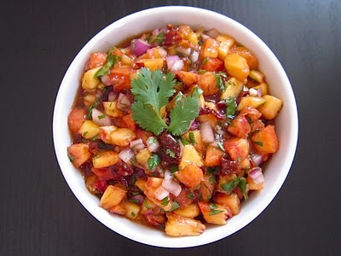
Peach Salsa

A nice sweet spicy salsa for chips or pita bread.

Makes 2 cups

2 medium ripe peaches, peeled, putted and chopped
1/2 cup onion, chopped
1/2 cup green bell pepper, seeded and chopped
1 tbsp freshly squeezed lemon juice
1 tsp lemon zest
1 jalapeño pepper, seeded and chopped

1. In a medium bowl combine peaches, onion, bell pepper, lemon juice, lemon zest and jalapeno pepper.
2. Let sit for 1 hour prior to use for flavors to blend.

